**Brick Bouncer**

1. Delete Sprite 1 (the cat)
2. Create a backdrop as a bitmap graphic.

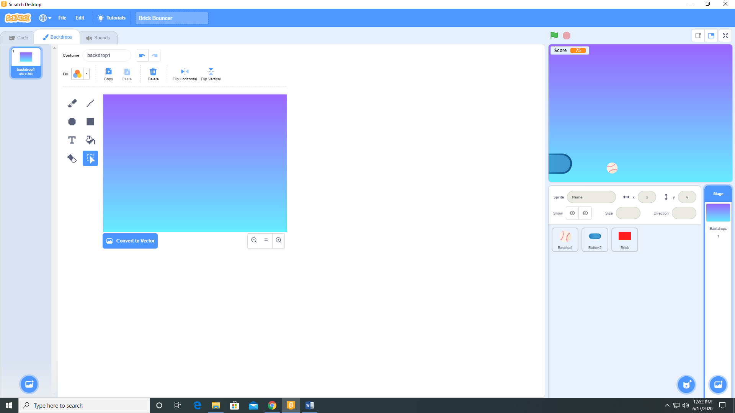

1. Add a variable Score for all sprites and visible on the stage.
2. Add a sprite (Button 2) from the sprite library. Add the sound Boing from the sound library to that sprite.
3. Add a sprite (Baseball) from the sprite library. Add the sound Alien Creak 2 from the sound library to that sprite.
4. Paint a sprite (Brick).

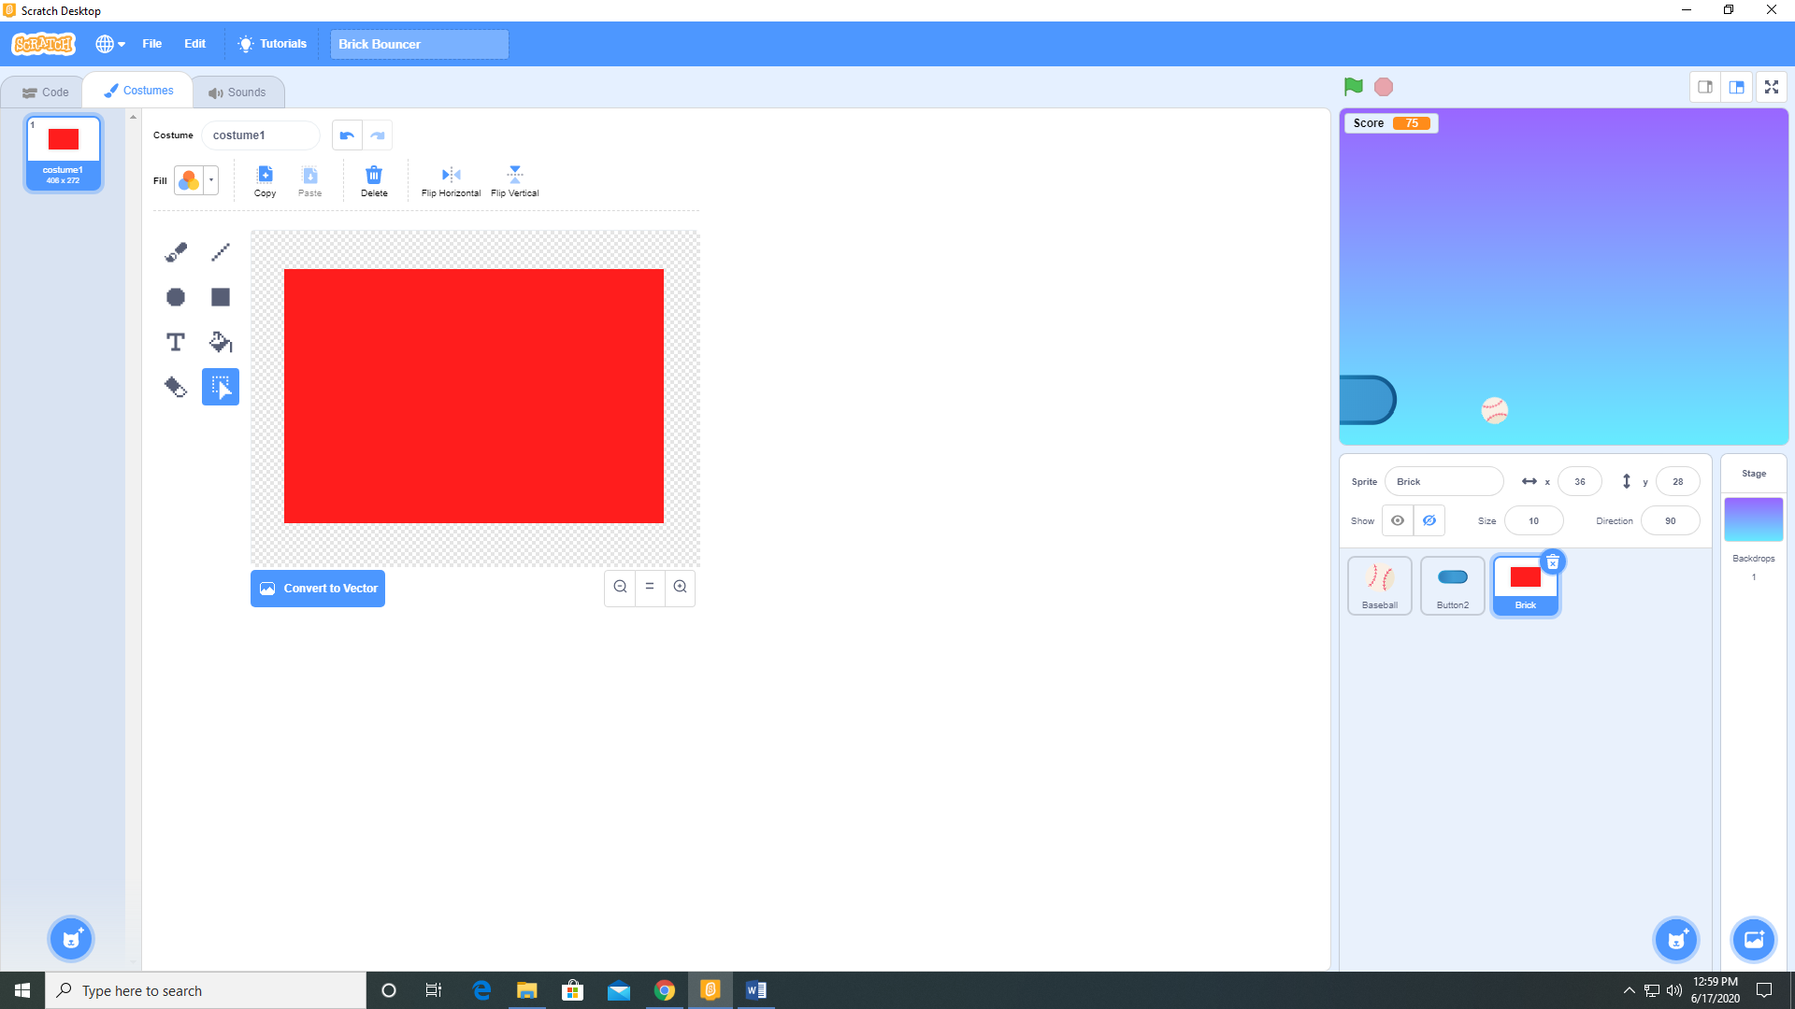

1. Add the following code to the Baseball sprite.

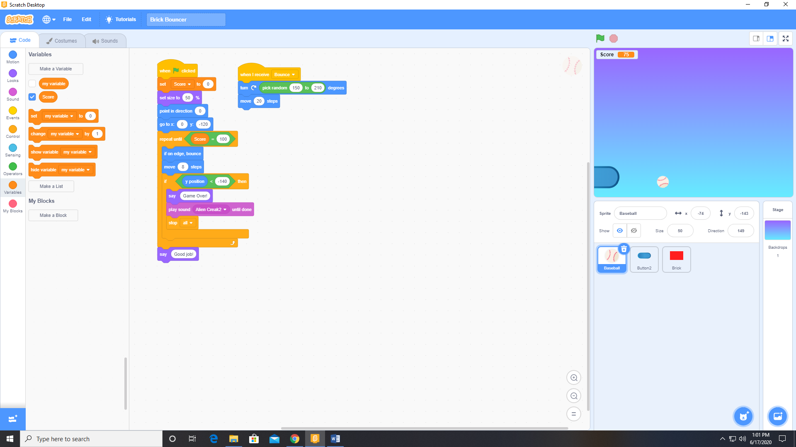

1. Add the following code to the Button 2 sprite.

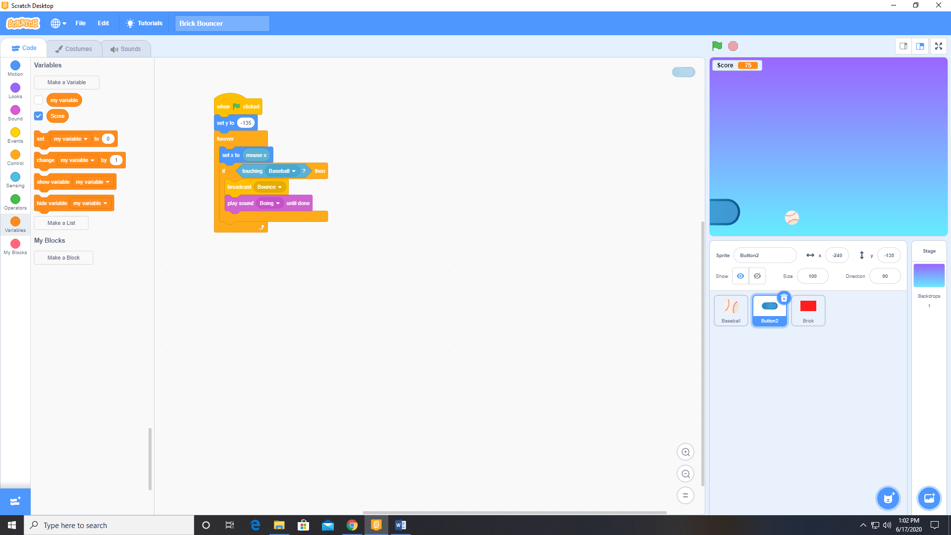

1. Add the following code to the Brick sprite.

